**Working of a RC car**

To understand the working of the RC car we will first have to look at wireless transmission. Wireless transmission uses electromagnetic waves to exchange energy. It utilises antenna’s for receiving and transmitting these electromagnetic waves.

There are 2 types of antenna’s: directional antenna’s and omnidirectional antenna’s. The directional antenna transmits and receives electromagnetic waves in just 1 direction while the omnidirectional antenna can receive electromagnetic waves in all directions. Let’s start with the directional antenna.

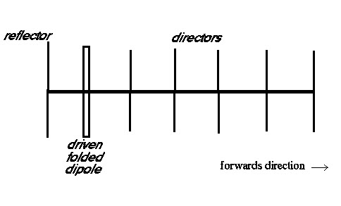

Transmission

There is current flow in the driven folded dipole part of the antenna which creates a magnetic field around it. This magnetic field will create an electric field in a nearby conductor such as one of the directors. This process repeats a couple of times in the directors so that the propagating wave will be stronger which includes it can send more energy. The more directors you have, the more gain the electromagnetic wave will have. Now there also is a part of the magnetic field that will be generated in the opposite directions so normally we would lose that part but by putting a reflector behind the driver, there will be an electric field created in the reflector which again creates another magnetic field. However, there is still a small magnetic field in the opposite direction caused by the reflector which remains unutilised.

Receiving

An electromagnetic wave from the outside generates an electric field in the directors. This electric field will generate a magnetic field around the director. This process repeats a couple of times until reaching the driver folded dipole. The electric field in the driver will cause current flow in the circuit its connected to. The reflector reflects part of the magnetic field back to the driver however there will still be a small part of the magnetic field in the opposite direction.

This directional transceiver is a Yagi antenna. Note that the reflector is slightly bigger than the driver and the directors get smaller when nearing the outer director.

The next antenna is the omnidirectional antenna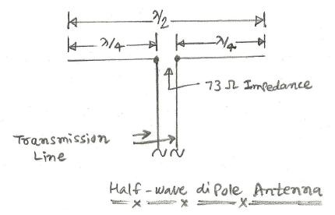

Transmission

In the transmission line flows a current that generates a magnetic field. At the feed, using the right-hand rule, you can see there is no magnetic field because both lines block each other out. However, on the top side the current flows in the same direction on the pane which makes it possible to generate electromagnetic waves. The wave that is generated is a torus around the antenna. 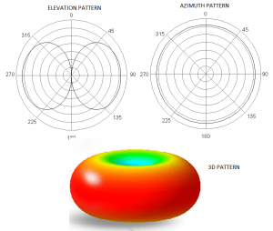

Receiver



An incoming electric wave generates a potential difference in the antenna allowing current to flow in the conductor. This current will flow into the circuit.

Now we understand how electromagnetic waves work so let’s look back at the RC car again. The controller has an antenna which works as a transmitter of electromagnetic waves. Now to give different commands to the receiver the rc car controller uses frequency modulation. That means each command has a different frequency. For instance, if you want to steer and accelerate at the same time, the controller is sending 2 electromagnetic waves with different frequencies so the receiver knows which frequency will activate the servo and which frequency will activate the motor.